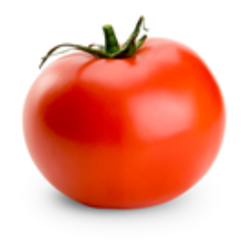
It’s…………………
We can make………….
It’s from…………

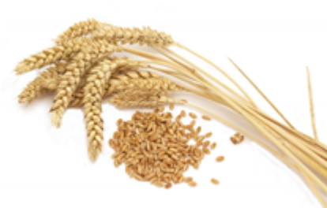It’s…………………
We can make………….
It’s from…………

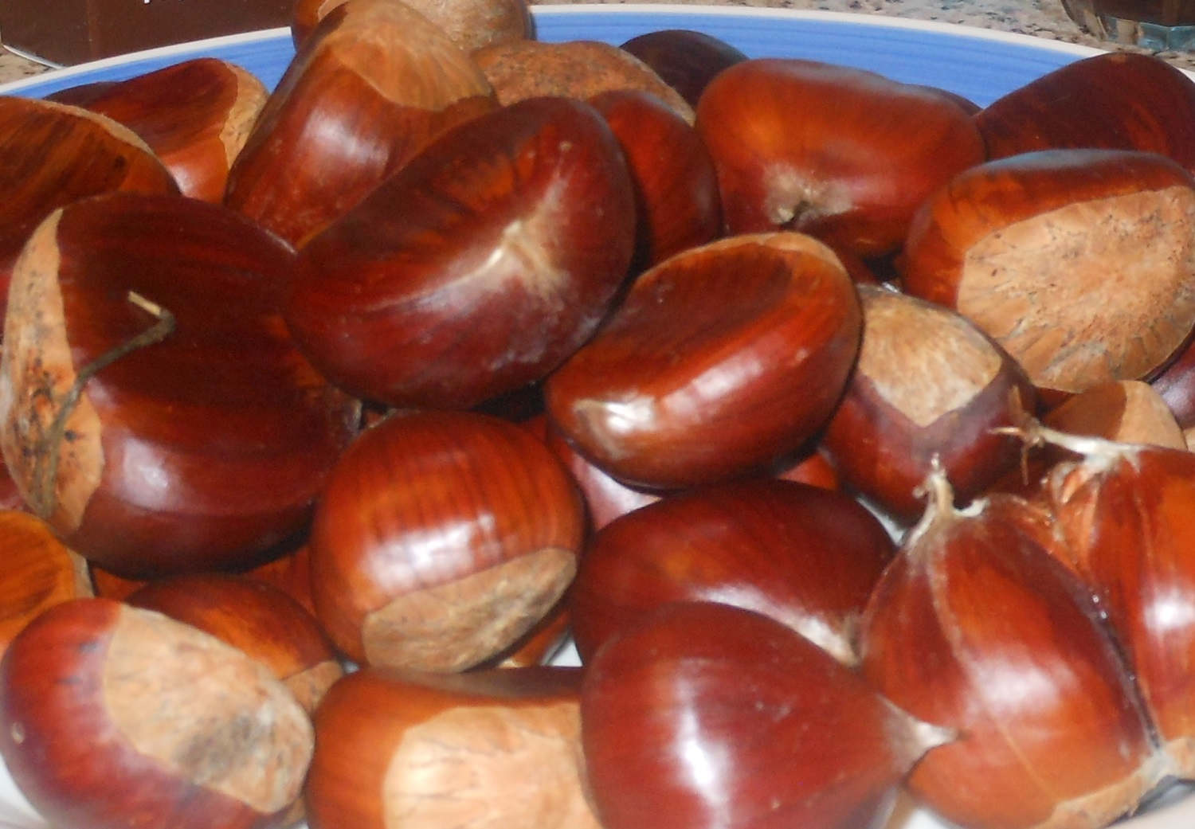
They are…………………
We can make………….
They are from…………

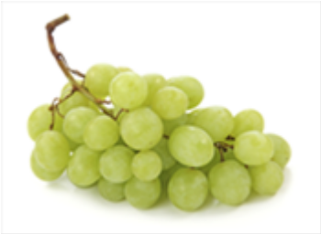It’s…………………
We can make………….
It comes from…………

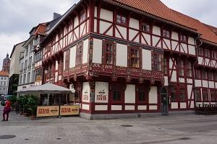
Is this house old or new?
Where is it from?

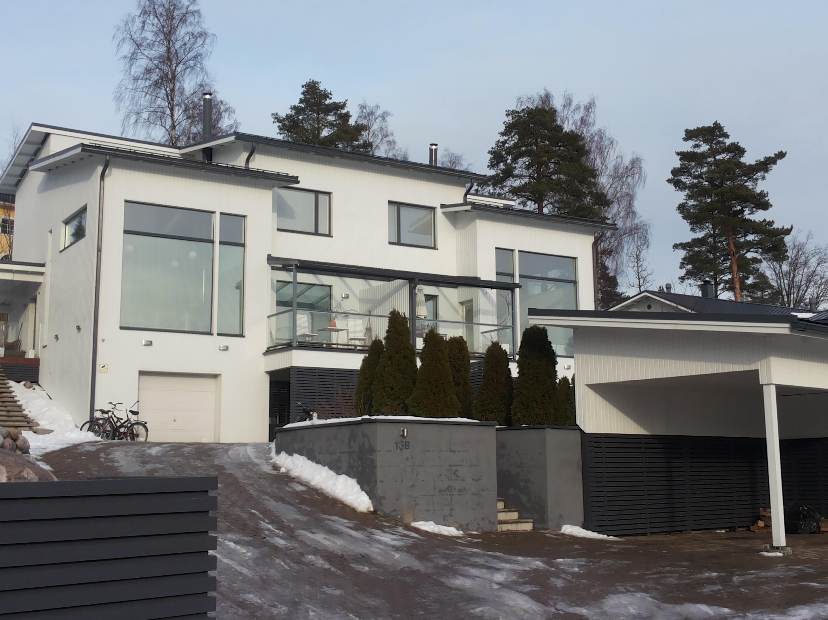
Is this house old or new?
Where is it from?

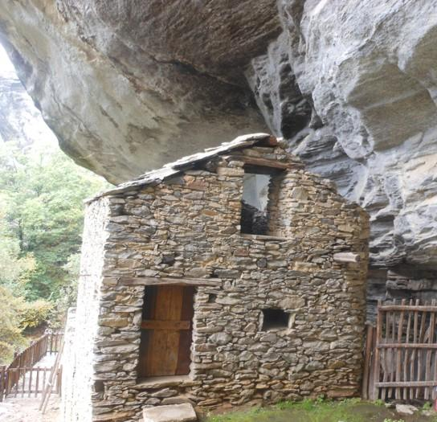
Is this house old or new?
Where is it from?

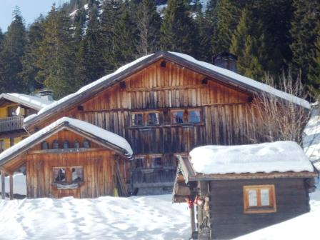
Is this house old or new?
Where is it from?

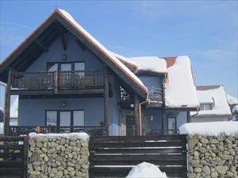
Is this house old or new?
Where is it from?

